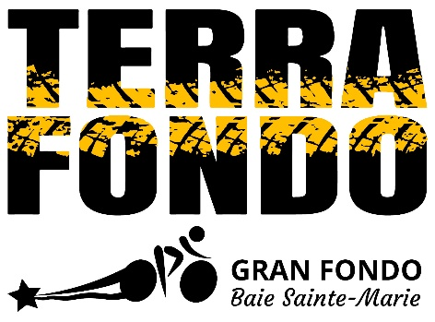

**Opportunité de commandite!**

**Sponsorship Opportunity!**

De retour pour la troisième année, le comité organisateur du Gran Fondo Baie Sainte-Marie organise un trajet à vélo de montagne le dimanche 9 juin 2024! Le Terra Fondo offre deux route (24 et 68 kilomètres) le long du système Rails-to-Trails et autres sentiers. Afin d’assurer le succès de notre événement, nous nous fions à l’appui généreux de notre communauté d’affaires lors de notre recueil de commanditaires. Votre participation comme commanditaire produira de ce troisième Terra Fondo un évènement spectaculaire tout en vous offrant la possibilité de bénéficier d’une visibilité accrue.

Back for the third year, the Gran Fondo Baie Sainte-Marie organizing committee is putting on a mountain bike ride on Sunday, June 9, 2024! The Terra Fondo offers two routes (24 and 68 kilometers) along the Rails-to-Trails system and other trails. To ensure the success of our event, we rely on the generous support of our business community during our sponsorship drive. Your participation as a sponsor will make this third Terra Fondo a spectacular event, while offering you the opportunity to benefit from increased visibility.

|  |  |  |  |
| --- | --- | --- | --- |
| Sponsor Benefits | Participant  T-Shirt Sponsor  $500 | Volunteer t-shirt sponsor  500$ | Spokes of the wheel  (other cash amounts, food/beverage, prizes, Swag bag item, etc.) |
| # Available: | **1** | **3** | **unlimited** |
| Social Media promotion | ✓ | ✓ | ✓ |
| Logo and link on website | ✓ | ✓ | ✓ |
| Logo on flyers and print materials | ✓ | ✓ | ✓ |
| Use of sponsor’s branded material/  equipment on site (ex: tent) | ✓ | ✓ | ✓ |
| One-color logo on back of event apparel  (long-sleeve t-shirts) | ✓ |  |  |
| One-color logo on back of volunteer t-shirts |  | ✓ |  |
| Deadline to become a sponsor: | May 10 | May 10 | June 1 |

**SPONSORSHIP FORM**

**SPONSORSHIP LEVEL (check one)🗹**

**PARTICIPANT T-SHIRT SPONSOR $500 🞎**

**VOLUNTEER T-SHIRT SPONSOR $500 🞎**

**SPOKES of the WHEEL* 🞎**

**\***Spokes of the Wheel sponsor:Please specify contribution (ex: other cash amounts, food, prizes, swag bag item, etc.).

I will donate: _________________________________________

*The Gran Fondo Baie Sainte-Marie team is committed to promoting a healthy event and, as such, requests that special consideration be given to the nutritional benefits of food/snacks/drinks provided and/or donated. Foods that are high in sugar, fats, and sodium and/or have little to no nutritional value could conflict with the health benefits of the event and the participants' optimal performance. Please contact us with any questions or for clarification. Thank you for your support!*



**DEADLINE JULY 10th, 2019**

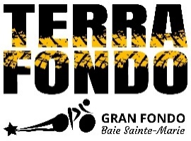

Company name: _________________________________________________________________________________

How would you like to be listed on event signage and advertising? _________________________________________

_______________________________________________________________________________________________

Contact person: __________________________________________________________________________________

Address: ________________________________________________________________________________________

Phone: _________________________________________________________________________________________

Email: __________________________________________________________________________________________

PLEASE SEND **COMPANY LOGO** BY EMAIL TO: [cdo@munclare.ca](mailto:cdo@munclare.ca)

PLEASE MAKE CHEQUE PAYABLE TO: Municipality of Clare

AND SEND TO: Municipality of Clare (Terra Fondo) 1185 Hwy 1, Little Brook, NS, B0W 1M0

For more information, call 902-769-2031 to speak with Réanne Flynn.

Our committee will be in touch to work out all the details of your sponsorship once we receive your completed form.

**We thank you in advance for your consideration and we look forward to**

**hearing from you as you commit to becoming a sponsor and a part of our**

**third Terra Fondo’s success!**